Assignment ATG Terminal

Create a Java desktop application built with Maven. Upload the source code on any web hosting with support for Git, for example GitHub, Bitbucket, GitLab or something similar.

The application should have the following GUI:

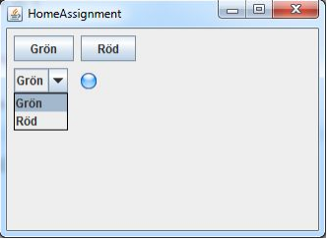

Use Maven to build a distribution that consists of a file that can be unpacked and can easily be run by a non-developer on any computer with Java preinstalled.

The application should use at least one open source library, for example log4j, which is included as a Maven dependency.

You should be able to show how to clone the project to a local computer and work with the project in the development environment you prefer.

If you don’t have your own computer that you can bring, please let us know which OS and development environment you prefer and we will arrange it.